What is the SCA?
The SCA is a non-profit organisation devoted to pre-seventeenth century European culture. It was started in 1966, in Berkeley, California and is now an international club, with branches all over the world. There are New Zealand branches in Christchurch, Auckland, Hamilton, Wellington, Nelson and Dunedin.
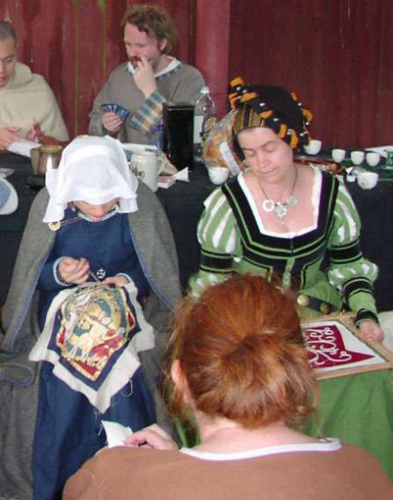

What is there to do?
An easier question is "what isn't there to do!?" It’s a hobby that encompasses many other hobbies. There are many skills and crafts we pursue, including but not limited to:

Archery, Armouring, Basketry, Bardic Recital, Brewing, Calligraphy, Candle Making, Cooking, Costuming, Dancing, Drawing, Dyeing, Embroidery, Equestrian Pursuits, Falconry, Gaming, Heraldry, Herb Lore, Illumination, Jewellery Making, Leatherwork, Music, Medieval Combat, Rapier Fighting, Scribing, Sewing, Spinning, Tanning, Weapon Smithing, Weaving, and Woodworking. Plus of course the research that goes into all of these.

How do I find out more?
The SCA is organised along medieval lines, with Kingdoms, Principalities, Baronies, Shires, Cantons, and Hamlets.

The Christchurch branch is the Barony of Southron Gaard, and we have a Baron and Baroness who preside over us, on behalf of our King and Queen. We are part of the Kingdom of Lochac, which includes Australia and New Zealand.

Find out more about the Barony at www.southrongaard.sca.org.nz
or read about the Kingdom of Lochac at
https://lochac.sca.org
and the SCA in general at
www.sca.org

How do I get started?
Just show up to any of our meetings, events, classes, or demonstrations! We love meeting new people. Our calendar of events is online at www.southrongaard.sca.org.nz/calendar.shtml or subscribe to our mailing list (ask the Chatelaine, email on back page).

The Chatelaine is the newcomers’ contact, and is there to help you make sense of everything. From "how do I make my own medieval clothes?" to "what do I need to bring to an event?" the chatelaine can help you get started. The Chatelaine can also help with costumes and feast gear (medieval plates and drinking vessels).

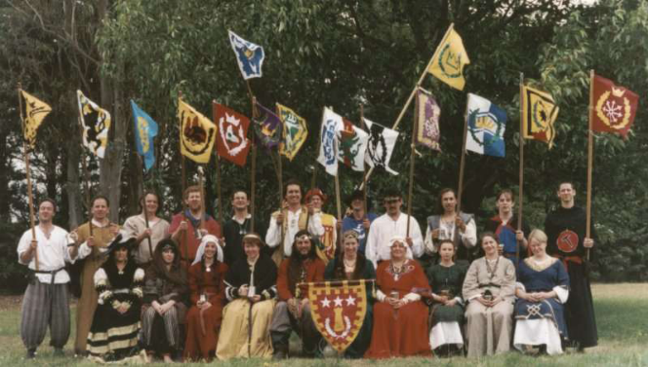

Contacts:
Website: www.southrongaard.sca.org.nz
Facebook: www.facebook.com/SouthronGaard/

Chatelaine (newcomers contact)
E-mail: chatelaine@sg.lochac.sca.org
Marshal (combat sports)
E-mail: marshal@sg.lochac.sca.org
Arts and Sciences (crafts)
E-mail arts@sg.lochac.sca.org
Seneschal (club President)
E-mail: seneschal@sg.lochac.sca.org

Person you spoke to today:
_____________________
_____________________
_____________________

PLEASE NOTE: THIS IS NOT AN OFFICIAL PUBLICATION OF THE SCA NOR DOES IT DELINEATE SCA POLICIES.

S.C.A. Combat
Medieval combat with swords, shields, and
armour attracts much attention. It is often one of
the first activities that a newcomer wants to try.
Both men and women actively participate.
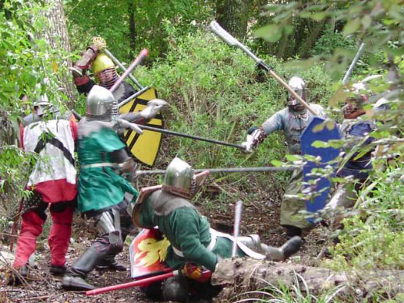

As in any sport, there are rules and regulations to
ensure the safety of the players (and spectators).
The "Rules of the Lists" set out the Society'
standards on weapons and armour, and how hard
the fighters are allowed to hit each other. The
SCA has a good safety record and we consider
our sport safer than playing rugby, however, as
with any sport, there is an inherent risk involved.

We try to make participants aware of the
dangers, and insist on responsible behaviour.
Most local groups offer some form of fighter
training. A fighter must be authorised to fight in tourneys and wars. Authorisation is done to confirm that the novice knows the rules of combat and is sufficiently skilled so that he or she will not be a danger to himself or to others on the field.

Fighters are responsible for obtaining their own
armour and weapons. Some people make most of
their armour, using metal, leather, or plastic, but
most buy pieces, either new or used. Substandard
equipment is not allowed, so before making any armour, or weapons you will need to contact your local marshal and get a copy of the safety standards and requirements.

What's with all the funny names?
Everyone in the Society creates a persona, a
person that they could have been if they had
lived in the Middle Ages. Some people only go
so far as selecting a name, while others create
and write entire histories of the person, their
family, and how events of their time period
affected them. Which of these you do is entirely
up to you.

When developing a persona thinking about your
interests, which aspects of the society you want
to get involved with, and what parts of the
Middle Ages you like most. Are you intrigued by
Queen Elizabeth's court? Perhaps your interests
lie in the Persian Empire? Maybe you are a big,
bold Scotsman from the Highlands? Whatever
your interest, a persona can incorporate them.

You can use your real given name to start with, as working out what interests you and what persona to choose can take a while. We use the titles M’lord and M’lady to refer to anyone whose name we don’t know, so you will hear those terms often.
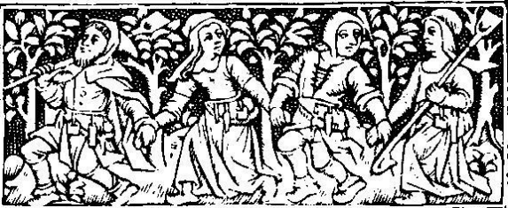

SCA

The Society for

Creative
Anachronism
(NZ) Inc.
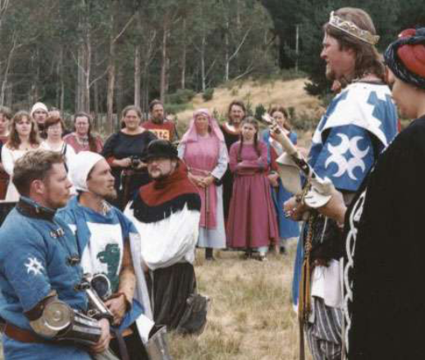

A medieval history and
recreation club

